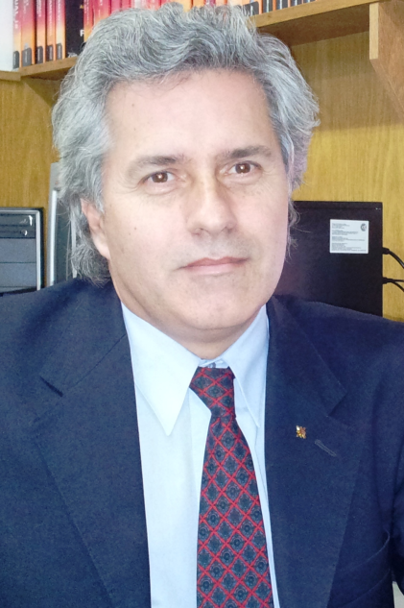

Carlos De Candia,
Transporte y Tecnología Ferroviaria
UTN/FRBA - SEcTIP
cdecandia@frba.utn.edu.ar
ferrocarriles@frba.utn.edu.ar
http://www.frba.utn.edu.ar/

International Level Crossing Awareness Day (ILCAD) on 7 June 2012

"This is the first year that the (National Technologic University- Buenos Aires Unit - UTN-FRBA) joins ILCAD and we are very pleased to support the efforts of the international community to promote safety at level crossings working in coordination with Operation Lifesaver Argentina and ALAF(Latin American Association of Railroads) that joined ILCAD already in 2009.

In particular, we are very concerned about the growing number of fatalities and injuries that occurred at level crossings throughout the country compared to statistical data available from other countries that take part in the ILCAD initiative.

Under the Secretary of Science, Technology and Productive Innovation (SECTIP-FRBA) the Railway Transport and Technology Group is working with the support of the Argentinian Railway Institute (Instituto Argentino de Ferrocarriles (IAF), organizations of public and private sectors, and the engineering areas of the University, in the development of activities in projects, investigation and new technologies in Railway Transportation.

As a result it is with great enthusiasm, and simultaneously with the fourth edition of ILCAD taking place on June 7, that the UTN-FRBA organize in Buenos Aires the first seminar on “Safety and Prevention at Level Crossings” in Argentina pointing out not only the educational achievements of the international campaigns but also the technological advances at level crossings as an important issue to contribute to a safer rail/ road interface. Worth mentioning that during the seminar we will broadcast to the audience, part of the pre-recorded video-conference organized between the FRBA and Railway Transport and Technology Group authorities in Buenos Aires and Ms. Isabelle Fonverne (ILCAD-UIC) on 30/05.

Besides the seminar, UTN-FRBA will participate in radio and TV programs, will distribute leaflets and posters, will publish ILCAD videos on internet, all this with the ultimate aim of raising awareness about the dangers of drivers, pedestrians and cyclists at level crossings."

